3. Proposed Framework: BT-CMRS

3.1 System Architecture and Actors

BT-CMRS adopts a three-tier architectural paradigm comprising the Physical Layer, Cryptographic Layer, and Ledger Layer [1]. This design addresses the fundamental privacy-transparency paradox in conflict mineral sourcing: regulatory frameworks demand proof of ethical origin, while mining operations in conflict-affected regions require protection of precise geographic coordinates to mitigate security risks and preserve commercial confidentiality [2], [3].
Physical Layer: Encompasses data acquisition at mine sites, including certified auditor inputs and optional IoT integrations for mechanized operations. Given connectivity constraints prevalent in artisanal and small-scale mining (ASM) contexts, this layer supports semi-digital reporting modalities through cooperative representatives, with raw GPS coordinates remaining in local secure enclaves [1].
Cryptographic Layer: Implements Zero-Knowledge Proof (ZKP) circuits utilizing Groth16 zk-SNARKs (Succinct Non-Interactive Arguments of Knowledge) over the BN254 elliptic curve for Ethereum compatibility [4]. This layer handles the mathematical transformation of precise GPS coordinates into region-compliance proofs using IEEE 754 floating-point arithmetic within hierarchical Discrete Global Grid Systems (DGGS), enabling adjustable granularity from broad regional levels to specific administrative boundaries [4], [5].
Ledger Layer: Operates on Ethereum blockchain technology, providing decentralized consensus and immutable transaction validation. Smart contracts deployed on this layer automate stakeholder registration, batch certification, and reacquisition validation without intermediaries [6], [7].
System Actors:
- Mining Cooperative/Mine Site: Originates mineral batches and generates ZKPs proving geographic compliance within certified regions without revealing exact coordinates .
- Logistics Provider: Records custody transfers and shipment status during transport via blockchain events.
- Smelter/Refiner: Validates ZKP proofs, processes mineral batches, and initiates reacquisition requests when quality or ethical violations are detected.
- Manufacturer: Final product integrator verifying conflict-free status through blockchain queries.
- Auditor/Regulatory Authority: Issues cryptographic certifications and verifies ZKP compliance without accessing sensitive supply chain details.

As illustrated in Fig. 1, the workflow begins when a mineral batch is registered at the mine site with a unique identifier and associated metadata. Instead of publishing exact GPS coordinates, the framework generates a region-based zero-knowledge proof showing that the batch originates from an approved mining zone. The proof, along with non-sensitive metadata, is submitted to a smart contract. After verification, the batch is stored as a blockchain record, with lifecycle updates through transport, processing, and manufacturing stages. If the batch is later rejected due to provenance concerns or certification irregularities, a reacquisition process is triggered through smart contract logic.
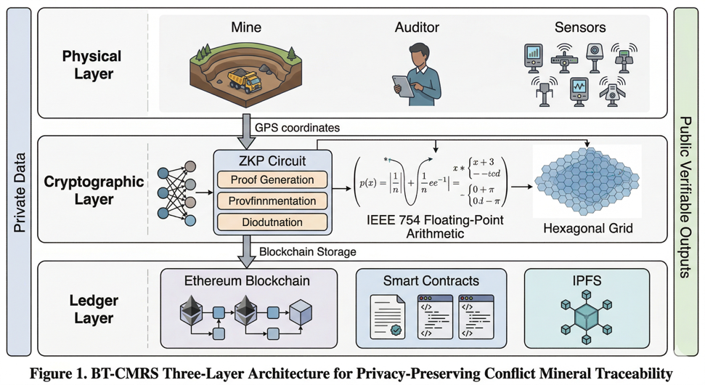

Figure 1. BT-CMRS Three-Layer Architecture for Privacy-Preserving Conflict Mineral Traceability

To formalize the overall workflow of the proposed system, Algorithm 1 presents the BT-CMRS framework for conflict mineral traceability and reacquisition. The algorithm begins with stakeholder registration and smart contract deployment, followed by batch creation, ZKP-based provenance verification, lifecycle tracking, and automated reacquisition handling.
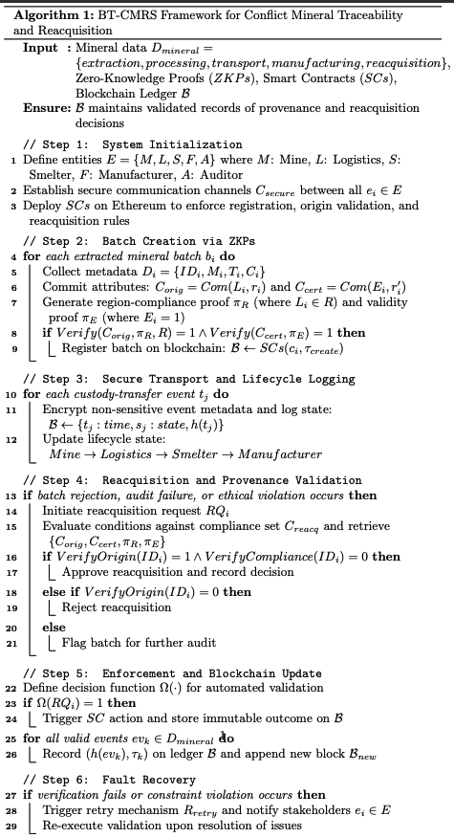
Algorithm 1. BT-CMRS Framework for Conflict Mineral Traceability and Reacquisition

3.2 Region-Based ZKP Scheme
The core novelty of BT-CMRS lies in its region-based zero-knowledge proof scheme, which allows a mining actor to prove that a mineral batch originates from a compliant region without revealing exact GPS coordinates. This design directly addresses the privacy–transparency paradox in conflict mineral sourcing. Conventional traceability demands proof of origin, but publishing exact mine coordinates or detailed route data may create security risks for mine operators and expose commercially sensitive information. Recent work on zero-knowledge location privacy shows that geographic predicates can be proven without disclosing the precise location itself, and that floating-point SNARK circuits can support accurate region-based spatial verification with configurable granularity [17]. This makes such an approach particularly suitable for conflict mineral systems where the required compliance question is often “Is this batch from an approved region?”, not “What is the exact coordinate of the mine?”
Let the mine location be denoted by the private coordinate pair
$$L=(x,y)$$
where $x$and $y$represent the latitude and longitude of the extraction site. Let $R$denote an approved certification region defined as a bounded polygon or administrative area:
$$R=\{(x,y)∣(x,y)\text{ lies within certified region}\}.$$
The compliance statement to be proven is:
$$S:L∈R.$$
Instead of disclosing $L$, the mining actor computes a commitment:
$$C=\text{Com}(L,r)$$
where $r$is random blinding data and $\text{Com}(⋅)$is a commitment function that binds the prover to the location without revealing it. The prover then generates a zero-knowledge proof $π_{R}$such that:
$$π_{R}←\text{Prove}(L,r,R)$$and the verifier checks:
$$\text{Verify}(C,π_{R},R)=1.$$
If the verification returns true, the smart contract accepts that the batch originates from an approved region, even though the precise location remains confidential. This design conceptually aligns with privacy-preserving provenance systems such as PrivChain and TradeChain, which show that ZKPs can protect sensitive supply chain facts while still enabling verification [15], [16]. However, BT-CMRS extends this logic specifically to conflict minerals by anchoring proof generation to certified geographic zones rather than open location disclosure.
The same structure can be extended to certification validation. Let $E$denote a certification status variable such that:
$$E∈\{0,1\}$$
where $E=1$means the batch is associated with a valid ethical or regulatory certification. A second proof $π_{E}$may be generated to show that the batch satisfies certification constraints without exposing the full certification file or intermediary details:
$$\text{Verify}(C_{E},π_{E})=1.$$
The combined proof structure therefore supports origin privacy and certification privacy at the same time. In practice, the mining actor provides proof that the batch is both region-compliant and certification-compliant, while the blockchain stores only commitments, proof outputs, timestamps, and lifecycle state changes. Sensitive data remain off-chain. This architecture is also consistent with recent smart-contract-based traceability literature showing that smart contracts are effective for process automation and tamper-evident traceability, while privacy-preserving layers are needed to avoid overexposure of business-critical data [18], [19].
Technical Specifications:
- Proving System: Groth16 (fast verification, small proof size ~200 bytes)
- Elliptic Curve: BN254 (Ethereum precompile compatibility)
- On-chain Verification Cost: Approximately 220,000 gas per proof
- Grid System: H3 Hexagonal Grid (DGGS Level 6-8 for regional granularity)

3.3 ZKP-Based Mineral Extraction Process
The mineral extraction stage is the first trusted entry point of the proposed framework. At this stage, the mine site or cooperative collects the minimum required data for traceability, including batch ID, mineral type, extraction date, and certification status. These attributes are necessary because responsible mineral supply chains depend on clear linkage between extracted material and subsequent transformations in the chain [12], [13]. However, unlike conventional systems, BT-CMRS does not write all raw upstream data directly to the blockchain. Instead, the framework stores only non-sensitive metadata and cryptographic commitments, while sensitive origin information is protected through the region-based ZKP described in Section 3.2.
As shown in Fig. 2, the extraction process contains four main stages: data collection, proof generation, smart contract verification, and blockchain storage. First, the mine site prepares a batch record. Second, the region-compliance and certification proofs are generated locally or through a trusted digital interface. Third, the proof package is submitted to the smart contract, which checks whether the batch satisfies the encoded compliance predicates. Finally, once the proof is verified, the batch is stored on-chain with a trusted state such as Registered, Verified, or Flagged. This method draws on the same privacy-preserving logic observed in earlier ZKP-enabled traceability models, but tailors it to mineral extraction where location confidentiality is more sensitive than in ordinary product supply chains [14]–[17].

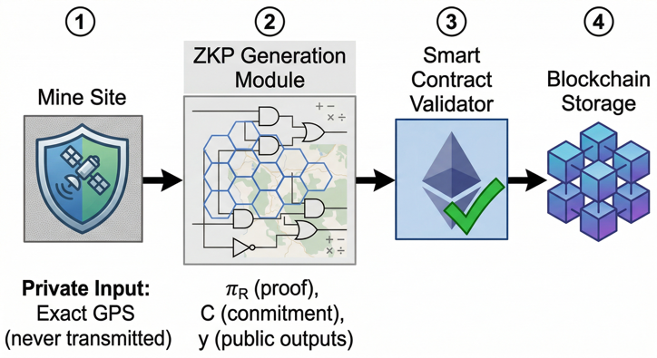
Figure 2. ZKP-based mineral extraction process showing data collection, proof generation, smart contract verification, and blockchain registration.
Formally, let the batch record be:
$$B_{i}=\{ID_{i},M_{i},T_{i},C_{i}\}$$
where $ID_{i}$is the batch identifier, $M_{i}$is the mineral type, $T_{i}$is the extraction timestamp, and $C_{i}$is the certification commitment. A valid extraction event occurs if both region and certification proofs are accepted:
$$\text{ValidExtract}(B_{i})=1 ⟺ \text{Verify}(C_{R},π_{R},R)=1∧\text{Verify}(C_{E},π_{E})=1.$$
If this condition holds, the contract records the batch as verified and emits an event to notify downstream actors. Otherwise, the contract rejects the batch or marks it for further audit. To formalize the extraction-stage workflow of the proposed framework, Algorithm 2 presents the ZKP-based mineral extraction process in BT-CMRS. The algorithm begins by receiving the batch ID, mineral type, extraction date, and certification data as input parameters. It then commits sensitive origin and certification attributes, generates the region-compliance proof $π_{R}$and certification-validity proof $π_{E}$, and submits the resulting metadata, commitments, and proofs to the smart contract. The contract verifies all proofs before making a final decision. If verification succeeds, the mineral batch is registered on-chain as a trusted extraction record; otherwise, the batch is rejected or flagged for further audit.
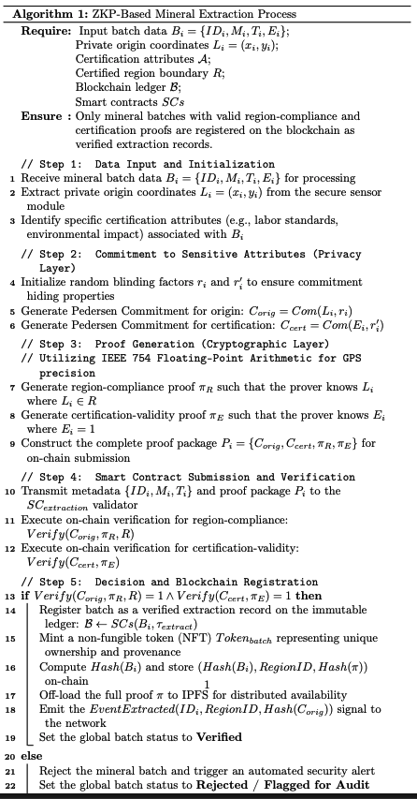

3.4 ZKP-Based Reacquisition Process
In BT-CMRS, reacquisition refers to the controlled return, quarantine, re-verification, or withdrawal of a mineral batch after it has already entered the supply chain. This process is triggered by events such as batch rejection, audit failure, or ethical violation. Unlike traditional mineral traceability systems, which mainly focus on forward movement from extraction to processing, the proposed framework explicitly supports reverse decision logic. This is important because disputed or non-compliant batches create significant financial and governance risks if they cannot be isolated and processed efficiently.
As illustrated in Fig. 3, the reacquisition process begins when a smelter, manufacturer, or auditor initiates a dispute over a batch. The initiating actor submits a reacquisition request referencing the batch ID and the relevant compliance concern. The system then generates or retrieves proof that the batch’s origin and certification chain satisfy or fail the necessary conditions. The smart contract evaluates the evidence and automatically issues one of three outcomes: Approve Reacquisition, Reject Reacquisition, or Flag for Audit. This automated decision model extends the broader logic of smart-contract-enabled traceability systems, which use encoded business rules for validation and state transitions [18], [19]. The difference is that BT-CMRS integrates this logic with privacy-preserving origin proof, rather than relying on full disclosure.
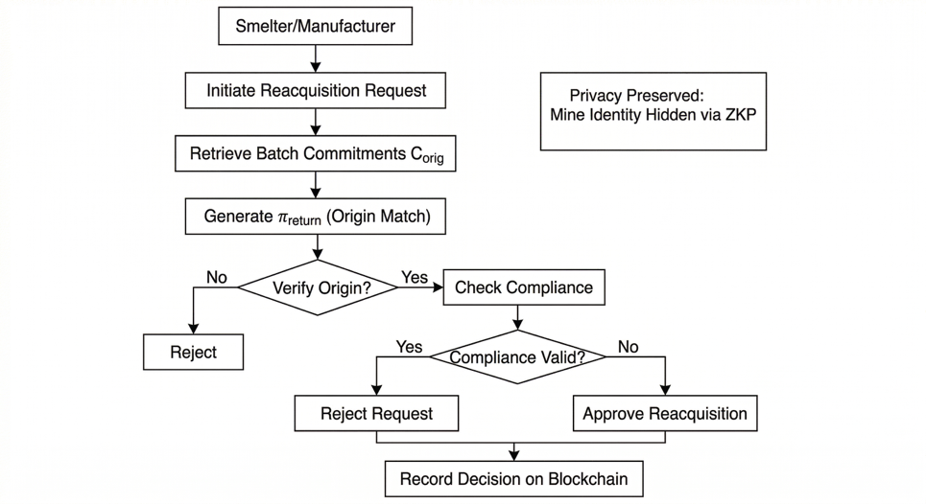
Figure 3. ZKP-based mineral reacquisition process showing dispute initiation, proof submission, contract-based decision, and immutable recording of the outcome.
Let a reacquisition request be represented as:
$$RQ_{i}=\{ID_{i},ρ_{i},τ_{i}\}$$
where $ID_{i}$is the batch identifier, $ρ_{i}$is the reacquisition reason, and $τ_{i}$is the request time. The contract evaluates origin and compliance evidence through:
$$\text{VerifyOrigin}(ID_{i})=1$$and
$$\text{VerifyCompliance}(ID_{i})=1.$$
The decision rule can be written as:
$$D_{i}=\left\{\begin{matrix}\text{Approve}, & \text{if VerifyOrigin}=1∧\text{VerifyCompliance}=0 \\ \text{Reject}, & \text{if VerifyOrigin}=0 \\ \text{Audit}, & \text{otherwise.}\end{matrix}\right.$$
This means that if the origin is valid but compliance has failed, the batch can be formally reacquired or withdrawn. If origin itself cannot be validated, the request is rejected or escalated. If the case is ambiguous, the batch is flagged for further audit. The final decision is written immutably to the blockchain, ensuring that downstream participants can verify the outcome without accessing the private raw evidence.
To formalize the reverse validation workflow, Algorithm 3 presents the ZKP-Based Reacquisition Process adopted in BT-CMRS. The algorithm begins by receiving a reacquisition request triggered by batch rejection, audit failure, or ethical violation. It then retrieves the corresponding batch commitments and proof references, generates or resubmits the required origin and compliance proofs, and submits the request to the smart contract for verification. Based on the outcome of proof validation, the contract issues one of three decisions: approve reacquisition, reject reacquisition, or flag the batch for further audit. The final reacquisition status is then immutably recorded on the blockchain.
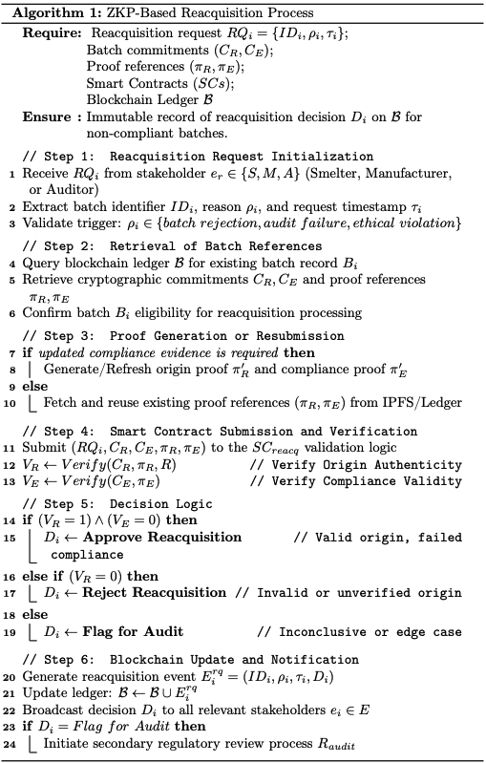

3.5 Security Analysis
The security of BT-CMRS depends on three interacting layers: blockchain immutability, smart contract enforcement, and zero-knowledge privacy preservation. Blockchain-based traceability systems are widely valued because each state transition is recorded in a tamper-evident ledger, making unauthorized modification of past events computationally difficult and operationally visible [18], [19]. In BT-CMRS, every extraction, transport update, certification verification, and reacquisition decision is stored as a blockchain transaction linked to the previous system state.
If $H(B_{i})$denotes the hash of block $i$, then:
$$H(B_{i})=\text{Hash}(H(B_{i-1}) ∥ D_{i} ∥ T_{i})$$
where $D_{i}$is the set of recorded transaction data and $T_{i}$is the timestamp. Any attempt to modify a historical batch record changes the block hash and breaks the chain consistency. This provides protection against data tampering and retrospective falsification.
The second layer is smart contract enforcement. Smart contracts encode the rules for stakeholder registration, proof verification, status transition, and reacquisition decisions. This reduces discretionary manipulation by ensuring that only valid proof-bearing transactions can alter the state of a mineral batch. Formally, if $SC(x)$denotes a contract function, then:
$$SC(x)=y\text{only if}x∈\text{ValidDomain}.$$
In other words, a batch state changes only when a submitted transaction satisfies the proof and access conditions defined by the contract.
The third layer is zero-knowledge privacy preservation, which addresses unauthorized access and location leakage. Traditional transparent traceability systems may reveal supplier structures, exact mine coordinates, or commercial relationships. In BT-CMRS, these are never exposed directly on-chain. Instead, the verifier only sees commitments and proof outputs. As shown in privacy-preserving blockchain literature, such selective disclosure reduces the risk of overexposure while still preserving trust in the verification outcome [14]–[17].
Taken together, this architecture improves resistance against four important risks:
- Data tampering: prevented by immutable blockchain storage and hash-linked records.
- Fake certification injection: reduced through proof-based certification validation before registration.
- Unauthorized access: limited because sensitive upstream attributes are never disclosed in plaintext.
- Location leakage: mitigated through region-based proof, which verifies compliance without revealing exact coordinates.
From a system perspective, BT-CMRS therefore provides a more balanced security model than either manual paper systems or plain transparent blockchain systems, because it combines integrity, automation, and privacy-preserving verification in a single traceability architecture.

References
[12] OECD, OECD Due Diligence Guidance for Responsible Supply Chains of Minerals from Conflict-Affected and High-Risk Areas, 3rd ed. Paris, France: OECD Publishing, 2016, accessed 2026.
[13] European Parliament, Traceability of Critical Raw Materials, with a Focus on Africa, 2024.
[14] S. Sahai, N. Singh, and P. Dayama, “Enabling privacy and traceability in supply chains using blockchain and zero knowledge proofs,” in Proc. IEEE Int. Conf. on Blockchain, 2020.
[15] S. Malik, V. Dedeoglu, S. S. Kanhere, and R. Jurdak, “PrivChain: Provenance and privacy preservation in blockchain enabled supply chains,” in Proc. IEEE Int. Conf. on Blockchain, 2022.
[16] S. Malik, N. Gupta, V. Dedeoglu, S. S. Kanhere, and R. Jurdak, “TradeChain: Decoupling traceability and identity in blockchain enabled supply chains,” 2021.
[17] J. Ernstberger, C. Zhang, L. Ciprian, P. Jovanovic, and S. Steinhorst, “Zero-Knowledge Location Privacy via Accurate Floating-Point SNARKs,” 2024/2025.
[18] E. Yiğit and F. Longo, “Improving supply chain management processes using smart contracts in the Ethereum network,” Applied Sciences, vol. 14, no. 11, 2024.
[19] M. J. Fernández-Iglesias, “Efficient traceability systems with smart contracts,” Applied Sciences, vol. 14, no. 23, 2024.

